JAVASCRIPT PROGRAMMER
FINAL INTEGRATED SUPERVISED
ASSESSMENT (FISA)
REMEDIATION
VERSION B – REMEDIATION
Customer Warranty Claim Tracker
FISA REMEDIATION ASSESSMENT – STUDENT PAPER (WORD DOCUMENT)

Skills Programme | SP-220373: JavaScript Programmer
Curriculum / module coverage | 900219-000-00-00 | KM-01, KM-02 and KM-03
NQF level / credits | Level 4 / 60 credits
Remediation date | 14 October 2026
Remediation time / duration | 09h00 – 13h00 | 240 minutes (4 hours)
Remediation assessment total | 80 marks | Open-book practical assessment
Remediation competency standard | 75% | minimum 60 out of 80

Learner details
Full name | Haaroon Ryklief
ID / learner number | 9211085137085
Cohort / group | 1
Remediation date | 14 October 2026
GitHub repository URL | https://github.com/hryklief/SP220373FISARemediation.git
Electronic filename | SP220373FISARemediation

FISA Remediation Assessment Instructions
Remediation sitting: 14 October 2026 | 09h00 – 13h00 | 4 hours
Open-book remediation assessment
- This remediation assessment carries 80 marks and is completed using this Word document together with your working project files and required Git/GitHub evidence.
- This remediation assessment is OPEN BOOK. You may refer to the approved SP-220373 course content available on the LMS (KM-01 to KM-03 and PM-01 to PM-04) and printed notes/material that you have with you.
- You may use VS Code or another assessor-approved editor, browser Developer Tools, Git and your assigned GitHub repository where required by the assessment.
- Network access during the remediation assessment is limited to the approved LMS course content and your assigned GitHub repository. You may not use search engines, Stack Overflow, YouTube, online tutorials, public GitHub code search, other public repositories, or any other internet research source.
- You may not use AI tools of any kind. This includes ChatGPT, Copilot, Gemini, Claude, Codeium, Cursor AI, AI code generation, AI chat, AI browser extensions, or AI features inside VS Code or another editor. Any AI extension must be disabled and must not be used during the remediation assessment.
- Standard non-AI editor features such as syntax highlighting, formatting and normal code suggestions may be used, provided they are not generated by an AI assistant.
- You may not communicate with or obtain assistance from another learner during the assessment.

PERMITTED DURING REMEDIATION | NOT PERMITTED DURING REMEDIATION
✓ Approved LMS course content | ✗ Internet research or search engines
✓ Printed notes/material already with you | ✗ AI/chatbot/code-generation tools
✓ VS Code / approved editor with AI disabled | ✗ AI extensions/features in VS Code
✓ Browser Developer Tools | ✗ Stack Overflow / online tutorials / YouTube
✓ Your assessment project files | ✗ Public GitHub code search or copying external code
✓ Assigned GitHub repository | ✗ Messaging or assistance from another person
How to answer the remediation assessment
- You must build and test the working solution. A written description alone does not replace a required coding or Git action.
- Your working project files and repository history are the primary evidence. Use the response boxes to identify file names, commit/PR references and concise test/debug notes.
- Do not paste large blocks of source code into the Word document unless the question specifically asks for it.
- Save your work regularly. Use readable code, meaningful names, appropriate comments and consistent indentation.
- Submit the completed Word document, complete project folder and final repository link/reference using the method provided by the assessor.
Assessment integrity declaration
By continuing with this remediation assessment, you confirm that the work you submit is your own and that you will follow the open-book rules above.

Remediation assessment structure
Section | Assessment method | Questions / tasks | Marks
Section 1 | Coding practical | 6 | 60
Section 2 | Git and GitHub practical | 5 | 20
 | REMEDIATION TOTAL |  | 80
FISA Remediation Assessment: 80 marks | Competency standard: 75% (minimum 60 out of 80).
SECTION 1 | Coding Practical | 60 MARKS

Customer Warranty Claim Tracker
Workplace brief
A customer-service team needs a browser-based warranty claim tracker. The page must capture claimant information, store claim records, filter records, provide user feedback, and safely deal with invalid input or processing problems. The solution must demonstrate objects, arrays, DOM behaviour, validation, error handling and debugging.
Complete all six coding questions. Questions are arranged progressively: 2 Easy, 2 Medium and 2 Hard. Your working project files are the primary evidence. Each coding question carries 10 marks.
B1. Claim form and project structure
Create a web project using index.html, style.css and script.js and link the files correctly. Build a warranty claim form that captures claimant name, email, product code, claim category and claim description. Include an area for status messages and an area where claim records can be displayed. [10 marks]
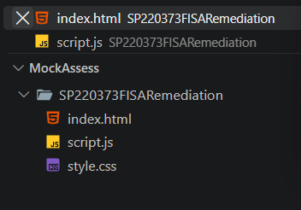

<!DOCTYPE html>
<html lang="en">
<head>
<meta charset="UTF-8">
<title>Warranty Claim Tracker</title>
<link rel="stylesheet" href="style.css">
</head>
<body>
<h1>Warranty Claim Tracker</h1>

<form id="claimForm">

<input type="text" id="name" placeholder="Claimant Name">

<input type="email" id="email" placeholder="Email">

<input type="text" id="productCode" placeholder="Product Code">

<select id="category">
<option value="">Select Category</option>
<option value="Hardware">Hardware</option>
<option value="Software">Software</option>
<option value="Accessories">Accessories</option>
</select>

<textarea
id="description"
placeholder="Claim Description">
</textarea>

<button type="submit">Submit Claim</button>

</form>

<h3>Status Message</h3>
<div id="message"></div>

<h3>Filter Claims</h3>

<select id="filter">
<option value="All">All</option>
<option value="Hardware">Hardware</option>
<option value="Software">Software</option>
<option value="Accessories">Accessories</option>
<option value="Pending">Pending</option>
<option value="Resolved">Resolved</option>
</select>

<h3>Claim Records</h3>
<div id="claimList"></div>

<script src="script.js"></script>

</body>
</html>

B2. Claim object and customer details
Create a claim object that contains an id, category, status and a nested customer object containing name and email. Add productCode and description to the claim. Display a readable summary of the claim on the page. Add a simple method or function that changes the claim status and demonstrate it on the claim. [10 marks]
let claims = [

{
id:1,
category:"Hardware",
status:"Pending",
customer:{
name:"John",
email:"john@gmail.com"
},
productCode:"A001",
description:"Screen fault"
},

{
id:2,
category:"Software",
status:"Resolved",
customer:{
name:"Mary",
email:"mary@gmail.com"
},
productCode:"A002",
description:"Activation issue"
},

function displayClaims(data){

const claimList =
document.getElementById("claimList");

claimList.innerHTML = "";

B3. Array of claims and filtering
Store at least four claim objects in an array. Use a loop or suitable array method to display a summary of every claim. Add a filter control that allows the user to show only claims matching a selected category or status. Update the displayed list when the selection changes. [10 marks]

let claims = [

{
id:1,
category:"Hardware",
status:"Pending",
customer:{
name:"John",
email:"john@gmail.com"
},
productCode:"A001",
description:"Screen fault"
},

{
id:2,
category:"Software",
status:"Resolved",
customer:{
name:"Mary",
email:"mary@gmail.com"
},
productCode:"A002",
description:"Activation issue"
},

{
id:3,
category:"Accessories",
status:"Pending",
customer:{
name:"David",
email:"david@gmail.com"
},
productCode:"A003",
description:"Keyboard fault"
},

{
id:4,
category:"Hardware",
status:"Resolved",
customer:{
name:"Anna",
email:"anna@gmail.com"
},
productCode:"A004",
description:"Battery issue"
}];

data.forEach(claim => {

claimList.innerHTML += `
<div class="claim-card">
<h4>${claim.customer.name}</h4>
<p>${claim.category}</p>
<p>${claim.status}</p>
</div>
`;
});
}

document
.getElementById("filter")
.addEventListener("change", function(){

const value = this.value;

if(value === "All"){
displayClaims(claims);
return;
}

const filteredClaims =
claims.filter(claim =>
claim.category === value ||
claim.status === value
);

displayClaims(filteredClaims);
});

B4. Validation and safe form processing
Handle the form submission with JavaScript. Validate claimant name, email, product code, category and description before adding a claim. Prevent invalid claims from being added to the array. Display clear validation and success messages using a text-safe DOM approach. Your email validation only needs to be suitable for the beginner level covered in the course content. [10 marks]
function validateEmail(email){

return email.includes("@")
&& email.includes(".");
}

const form =
document.getElementById("claimForm");

form.addEventListener("submit",function(e){

e.preventDefault();

const name =
document.getElementById("name").value.trim();

const email =
document.getElementById("email").value.trim();

const productCode =
document.getElementById("productCode").value.trim();

const category =
document.getElementById("category").value;

const description =
document.getElementById("description").value.trim();

const message =
document.getElementById("message");

if(
!name ||
!email ||
!productCode ||
!category ||
!description
){
message.textContent =
"All fields are required";
return;
}

if(!validateEmail(email)){
message.textContent =
"Invalid email address";
return;
}

message.textContent =
"Validation successful";
});

B5. Error handling during claim processing
Use try...catch...finally when processing a claim. In the try block, check one additional business rule after the normal form validation, for example that the claim description contains at least 10 characters. If the rule is not met, deliberately throw a clear Error. In catch, display a useful message to the user without crashing the page. In finally, display or set a simple message such as 'Processing complete'. Demonstrate one successful claim and one handled error. [10 marks]

try{

if(description.length < 10){

throw new Error(
"Description must be at least 10 characters"
);
}

const newClaim = {

id: Date.now(),

category,

status:"Pending",

customer:{
name,
email
},

productCode,

description
};

claims.push(newClaim);

displayClaims(claims);

message.textContent =
"Claim added successfully";

}
catch(error){

message.textContent =
error.message;

}
finally{

console.log("Processing complete");

}

Successful Claim

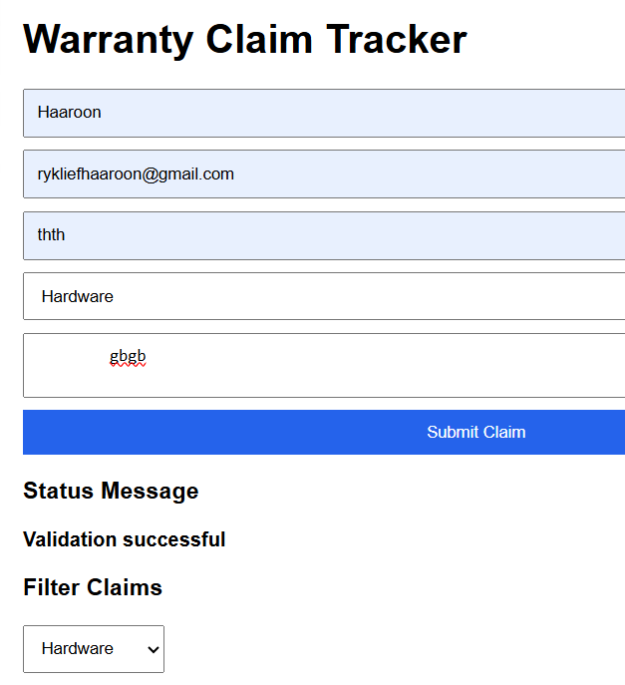

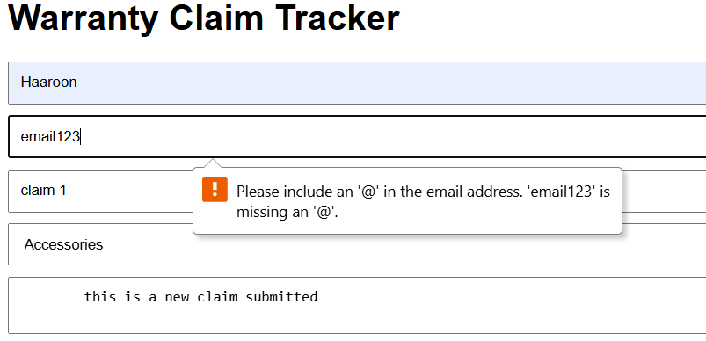

B6. Claim status update, testing and debugging
Extend the tracker so that each displayed claim has a simple control that changes its status from Open/Pending to Resolved. Update the correct claim object and the visible status on the page. Use the browser console and at least one breakpoint or step-through action to inspect the workflow. Run and record at least three tests: a valid claim, an invalid email, and a status-update or filter test. Correct any defect found and briefly record what you changed. [10 marks]
function displayClaims(data){

const claimList =
document.getElementById("claimList");

claimList.innerHTML = "";

data.forEach(claim=>{

const div =
document.createElement("div");

div.classList.add("claim-card");

div.innerHTML = `
<h4>${claim.customer.name}</h4>
<p>${claim.category}</p>
<p>Status: ${claim.status}</p>
<button onclick="resolveClaim(${claim.id})">
Resolve
</button>
`;

claimList.appendChild(div);

console.log(

)
});
}

//Change Status

function resolveClaim(id){

const selectedClaim =
claims.find(claim => claim.id === id);

if(selectedClaim){

selectedClaim.status =
"Resolved";

displayClaims(claims);

console.log(selectedClaim);
}
}

//Testing Evidence
//Test 1 Valid Claim

//Debugging Notes
console.log(claims);
//console.log(newClaim);

debugger;

SECTION 2 | Git and GitHub Practical | 20 MARKS

Complete all five Git/GitHub tasks using the same project from Section 1. Use only your assigned repository and the GitHub pages required for the task. Do not browse public repositories or use GitHub as a research source. Each task carries 4 marks.
B7. Connect local and remote repository
Connect the local project to the approved repository by cloning the repository or adding the correct remote to an existing local repository. [4 marks]
https://github.com/hryklief/SP220373FISARemediation.git

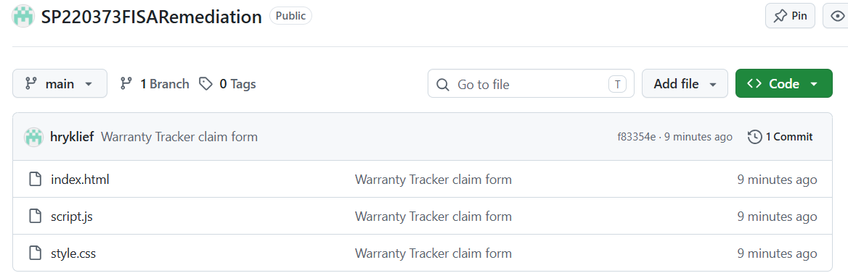

B8. Git status
Use Git status (or the equivalent view in an approved Git client) to identify changed and untracked files before committing. Briefly explain what the status information tells you. [4 marks]
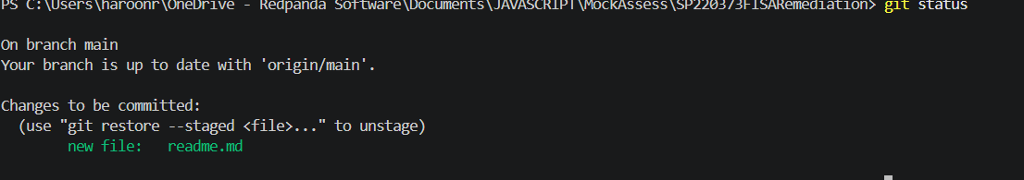
A readme file that’s currently staged and read for next commit

B9. Separate logical commit
Make a second logical change and record it as a separate commit rather than combining unrelated work into one large commit. [4 marks]
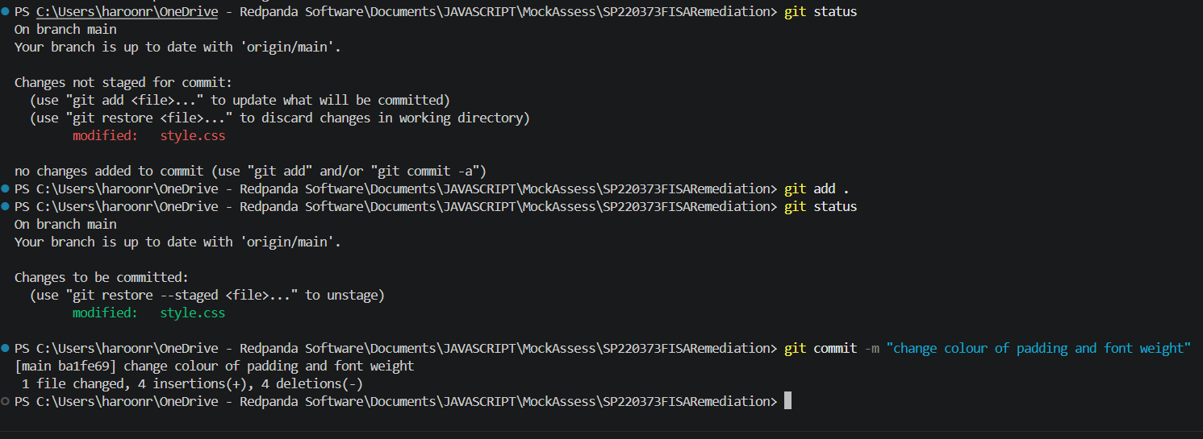

B10. Pull request review
Review a pull request and leave one useful review comment or approval note. Where another learner is not available, the assessor may act as the reviewer. [4 marks]
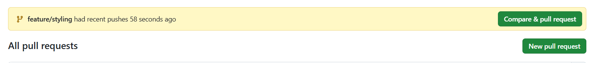

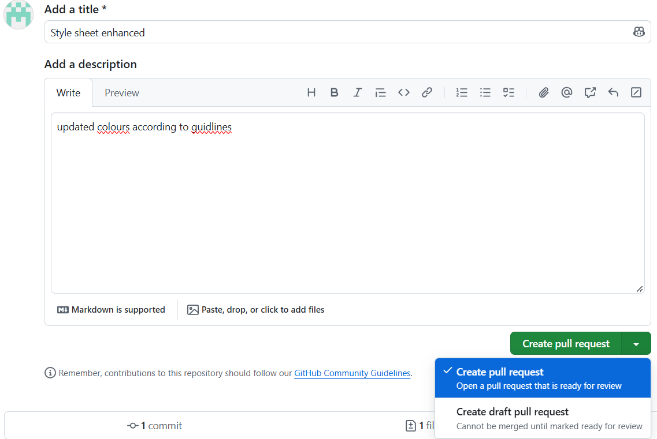

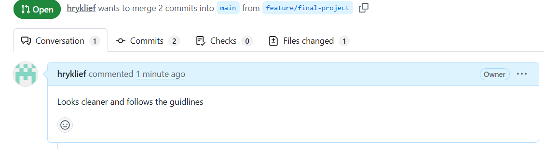

B11. Merge approved pull request
Merge an approved pull request and confirm that the main/default branch now contains the feature change. [4 marks]
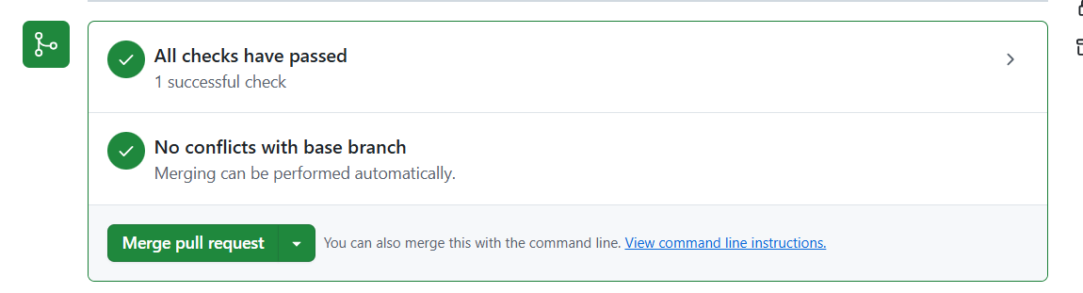

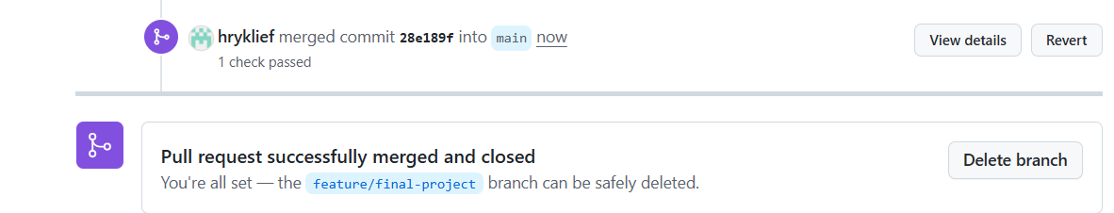

Learner declaration and remediation submission check
Learner declaration
I declare that the responses, project files and repository evidence submitted for this FISA remediation assessment are my own work. I used only the resources permitted in the remediation instructions and did not use AI, internet research, unauthorised code sources or assistance from another person.

Learner's typed full name | Haaroon Ryklief
Date completed | 10/14/2026
Final saved filename | SP220373 JavaScript FISA Remediation Version
Final project folder name | Click or tap here to enter details
Final repository URL / submission reference | Click or tap here to enter details
Final checklist
☐ My completed remediation Word document is saved.
☐ My project opens and runs.
☐ My JavaScript file(s) are included.
☐ My Git/GitHub evidence is complete.
☐ My repository link is correct.
☐ I have not used AI or internet research.

